**Road Accident Sql Queries**

**CURRENT YEAR CASUALTIES**





**CY_Accidents**





**CY_Fatal_Casualties**





**CY_Serious_Casualties**





**CY_Slight_Casualties**





**Number_of_Casualties by Month**



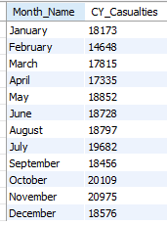

**Casualties by road type**

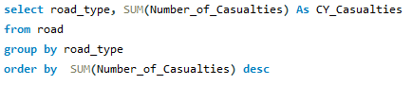

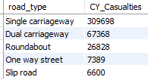

**Casualties by Urban/Rural**

